WISCONSIN RACING FORMULA SAE – SPROCKET FABRICATION PROCESS

UNIVERSITY OF WISCONSIN – MADISON, SPRING 2019

GALEN RILEY

JANUARY 23RD, 2019

1. START WITH STOCK MATERIAL – 8’’ DIA X 3.0’’ ROUND STOCK (7075 – T6 ALUMINUM).
2. SQUARE STOCK USING A LATHE AND TURN DOWN TO 7.6’’ DIAMETER.

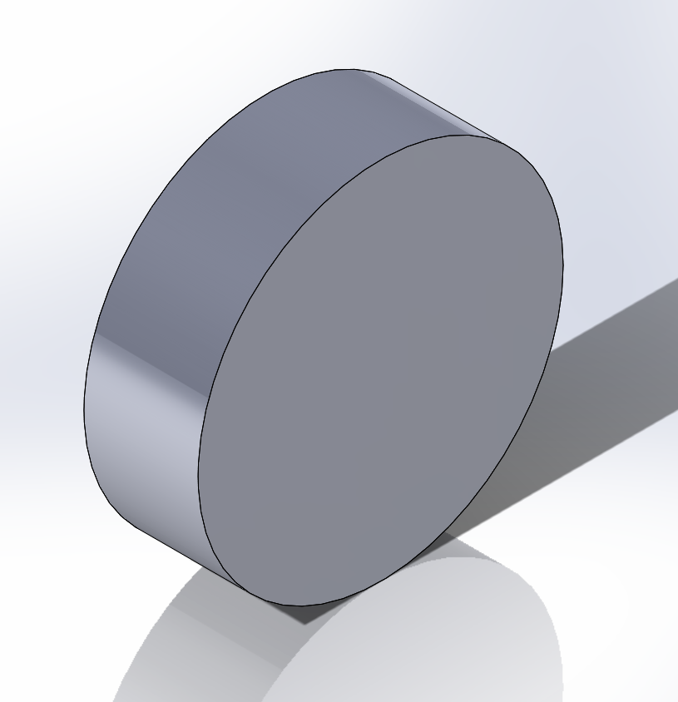

1. PROCEED TO BORE A HOLE WITH A 1.5’’ DIAMETER.

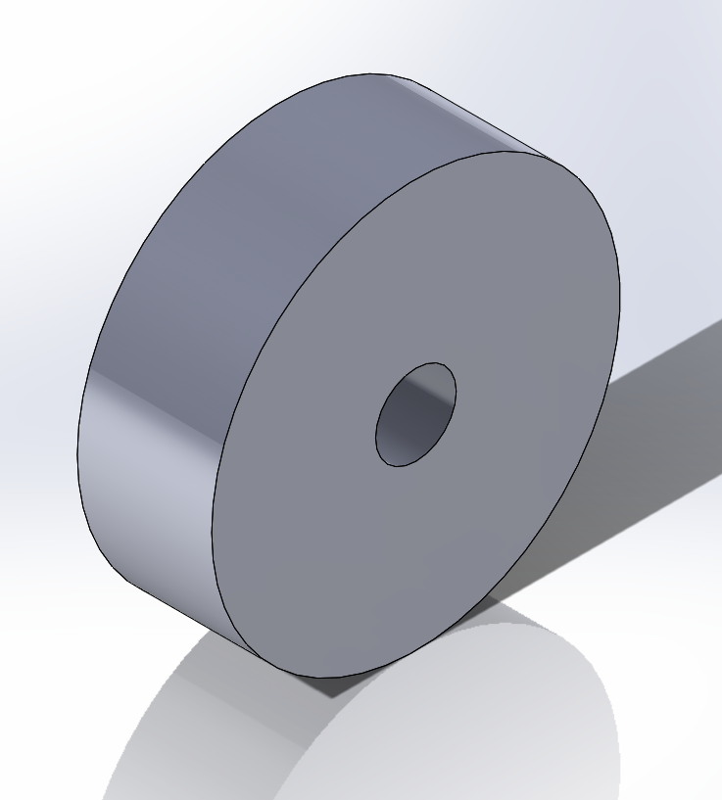

1. USING THE “T-REX” BAND SAW IN THE STUDENT SHOP, PART THE STOCK EXACTLY IN HALF. YOU SHOULD NOW HAVE TWO PIECE OF STOCK WITH A THICKNESS OF ROUGHLY 1.50’’
2. RETURN TO THE LATHE AND CUT EACH OF THE TWO PIECES DOWN TO THEIR FINAL THICKNESS OF 1.07’’ ENSURING THAT BOTH FACES ON EACH PIECE OF STOCK IS SQUARE.

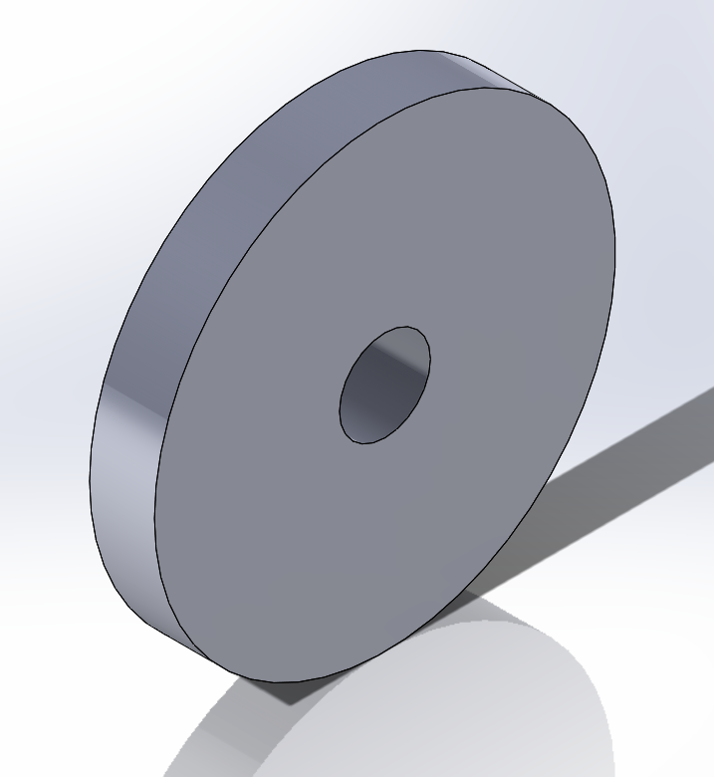

1. USING THE HAAS (OR A CNC LATHE), CAREFULLY FIXTURE THE PART UTILIZING THE BORED OUT FEATURE AND CUT THE SPROCKET PROFILE GEOMETRY INTO THE STOCK. (SANDING MAY BE REQUIRED).

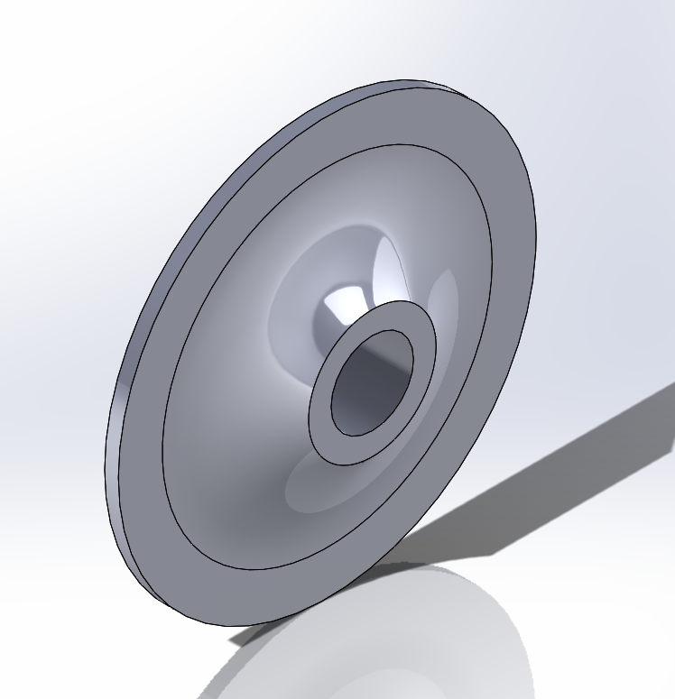

1. USING THE HAAS (OR A CNC LATHE), USE SIMILAR FIXTURING TECHNIQUES FROM STEP 6 TO CUT THE SPROCKET TOOTH TAPER INTO BOTH SIDES OF THE STOCK. (SANDING MAY BE REQUIRED).

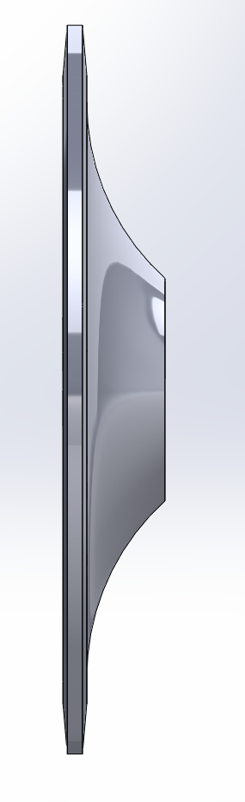 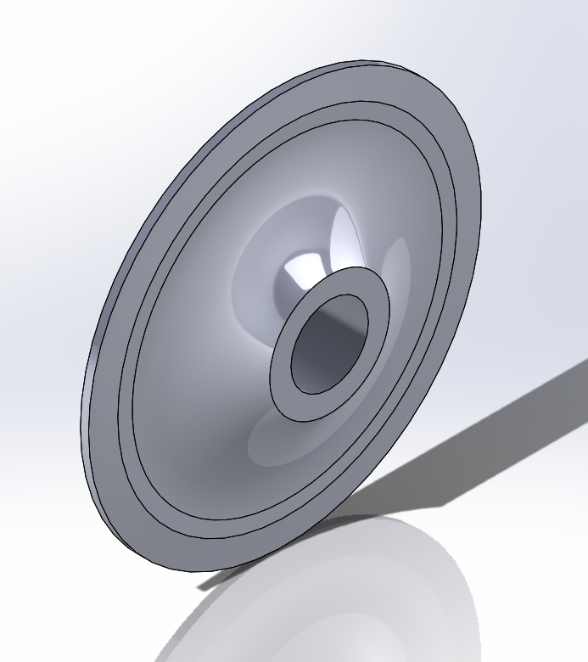

1. SEND STOCK TO WEASLER TO HAVE THEM WIRE EDM THE DIFFERENTIAL SPLINE GEOMETRY AND THE SPROCKET TOOTH GEOMETRY.
2. USING THE HAAS, CUT THE SPOKE GEOMETRY INTO THE SPROCKET.

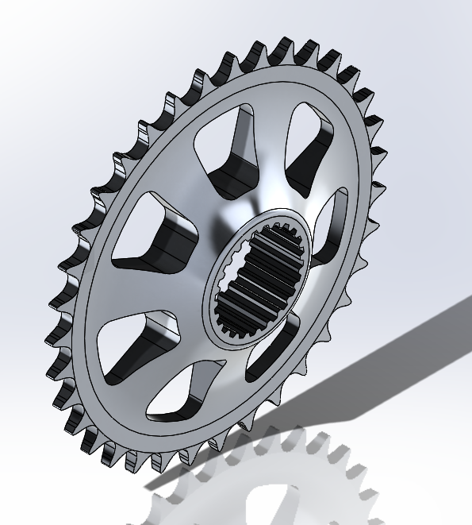

NOTE: CONSIDER REVERSING STEP 8 AND STEP 9 BASED OFF OF HOW EASY IT IS TO FIXTURE THE PART.